computer science - C++

Lesson 36: Binary Trees

OBJECTIVES: The student will define the following terms as applied to binary trees: root node, parent node, child node, leaf, levels, edge, and subtree.

The student will draw an ordered binary tree, given a set of data input to the tree.

The student will code a recursive insert algorithm to add data to an ordered binary tree.

The student will describe the best and worst cases for the data set used to construct a binary tree.

ACTIVITIES/TIME: Two Days
Day one: Presentation - 40 minutes
Lab Exercise - 10 minutes
Worksheet - Homework
Day two: Lab Exercise

MATERIALS: Student Outline O.A.36.1
Transparency T.A.36.1, Building a Binary Tree
Worksheet W.A.36.1, Binary Trees
Answer Sheet W.A.36.1
Lab Exercise L.A.36.1, BTree

REFERENCES: Adams, Joel, Sanford Leestma, and Larry Nyhoff. C++, An Introduction to Computing. Chapter 17.

Deitel, Harvey M. and Paul J. Deitel. C++ How to Program. Chapter 15.

Weiss, Mark. Algorithms, Data Structures, and Problem Solving with C++. Chapters 17 and 18.

INSTRUCTOR
NOTES: Binary trees are one of the classic data structures used to store and manipulate data. After covering the basic terminology of binary trees, an insert algorithm will be developed in this lecture. Lab Exercise L.A.36.1, BTree, will span Lessons 36, 37 and 38 as students learn the standard algorithms for manipulating ordered
binary trees. The problem that is being solved is the storage, traversal, search, and deletion of the same type of data as used in the binary search lesson and linked list labs (file20.txt), but with a new data structure.

A pseudocode version of a recursive function insert is provided here as reference. This location is left blank in the student outline. Students will learn more if they see the pseudocode developed step by step.

void insert (treePtr &temp, int id, int inv)
{
if temp points to NULL, insert data as a new node pointed to by temp
else
if (id < current node id)
recursively insert data to the left
else if (id > current node id)
recursively insert data to the right
}

The lab exercise for this lesson has students modifying the code from Lesson 33, the ordered linked-list lab. Students will revise the main menu choices and code only the insert function. The remaining menu choices should be stubbed-out, pending further instruction about binary trees in the next two lessons.

No answer sheet has been provided for the lab exercise. Refer to Answer Sheet L.A.38.1 in Lesson 38 for the entire answer to the BTree exercise.

The insert and delete algorithms developed in the answer sheet are recursive. The 3rd Edition Pascal version of the curriculum used iterative versions. This 4th Edition C++ version will model recursive problem-solving. Recursive solutions are both elegant and simple and you are encouraged to use recursion whenever possible when working with trees.

Student Outline

Lesson 36: Binary Trees

INTRODUCTION: A binary tree is a different kind of data structure which demands new terminology and algorithms. A binary tree node will have two pointers available for linking with other nodes, resulting in diagrams that look like inverted trees. A binary tree will begin with one node at the top and branch out below. As you might expect, the potential of going one of two different ways leads to some challenging programming problems. In fact, the idea of trying one direction, then backtracking must lead to recursion. The recursive algorithms used to traverse binary trees are very elegant and compact, but difficult to understand. But, one step at a time; first we need to learn how to talk about binary trees (vocabulary) and then build one (an algorithm).

The key topics for this lesson are:

A. Binary Tree Vocabulary
B. Building a Binary Tree
C. Shape of a Binary Tree

VOCABULARY: BINARY TREE ROOT NODE
PARENT NODE CHILD NODE
LEAF SUBTREE
LEVELS EDGE

DISCUSSION: A. Binary Tree Vocabulary

1. A binary tree is a data structure where each node has two pointers, each pointing to another node or a NULL value.
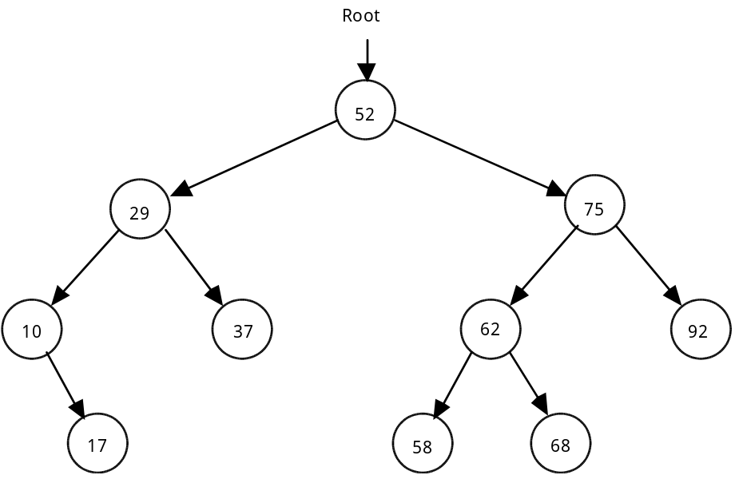

2. The following binary tree terms will be defined and applied to the above example.

a. Root node - the top node in the tree; the node whose value is 52.
b. Parent node - a node which points to one or two nodes.
c. Child node - the node being pointed to from a parent; every node in the tree is a child to another node, except for the root node.
d. Leaf - a node which has no children
e. Level - the distance from the root, calculated by counting the shortest distance from the root to that node. Examples: 29 is the value stored in a node at level 1, 62 is a value stored in a node at level 2, 17 is the value of a node stored at level 3, etc.
f. Edge - an edge joins two nodes. In the above diagram each arrow represents an edge.

3. This tree is an example of an ordered binary tree which has the following property. For every parent node, a child to the right will have a larger value, while a child to the left will have a smaller value.

4. A subtree is the entire left branch or right branch of a node. For example, the left subtree of the node containing 52 has 4 nodes. The right subtree of node containing 75 has only 1 node.

5. A leaf will have two NULL pointers.

B. Building a Binary Tree

1. The following definitions will apply in this next section on building a binary tree.

struct treeNode
{
int id, inv;
treeNode *left, *right;

treeNode (int, int, treeNode *, treeNode *);
};

treeNode::treeNode (int tempId, int tempInv, treeNode *tempLeft,
treeNode *tempRight)
: id (tempId), inv(tempInv), left(tempLeft), right(tempRight)
{
// all values initialized using initializer list
}

typedef treeNode* treePtr;

2. Suppose the following integers were inserted into a binary tree in this order:

26 79 14 99 53 9 35 21 87

Draw the resulting binary tree:

See Transparency T.A.36.1, Building a Binary Tree, for answer.

3. You will notice that new information was placed in the binary tree as a leaf. The insert algorithm will be a recursive solution.
4. Given this parameter list for function insert, develop the pseudocode below it.

void insert (treePtr &p, int data)
// Will insert data into an ordered binary tree. The solution is recursive.

C. Shape of a Binary Tree

1. The shape of a binary tree will affect its performance as a data structure and is dependent on the order of the data set.

2. If the data set came in as a sorted list (1 2 3 4 ...), the binary tree is essentially a linked list with an unused left pointer in each node.

3. A data set in random order will give a more balanced tree.

4. Ideally, we want binary trees that are balanced with almost equal numbers of nodes in each subtree of a node. The characteristic of a balanced binary tree is defined as follows: for every node in the tree, the number of nodes in its left subtree is equal to the number of nodes in its right subtree, plus or minus one. Balancing binary trees will not be covered in this curriculum guide.

SUMMARY/REVIEW: You have learned how to build a binary tree; but is it correct? We need to “see” the tree by printing it out in ascending order. Examine the binary trees developed in this lesson and think about the task of printing out the values in order. The next lesson will introduce you to a recursive solution to this problem, as well as a few other binary tree algorithms.

ASSIGNMENT: Worksheet W.A.36.1, Binary Trees
Lab Exercise L.A.36.1, BTree

